

**SCHOOL OF MECHANICAL AND MANUFACTURING ENGINEERING, NUST H-12**

**Name: Syed Amna Hasnain**

**CMS ID:467234**

**Course Code: AE-103**

**Section:AE-01**

**Assignment#01**

**Objective**

Create detailed and dimensioned orthographic projections of three objects in AutoCAD.

**Introduction**

**Object 1**

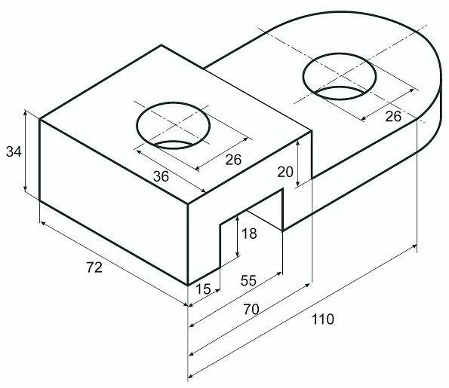

**Drawing:**

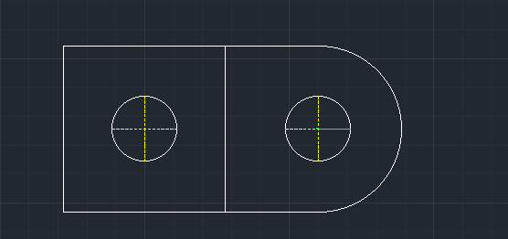

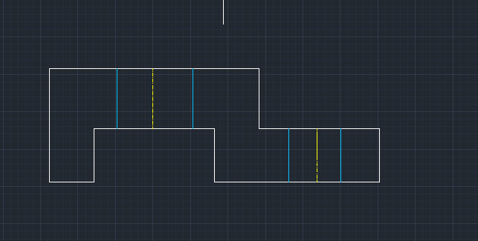

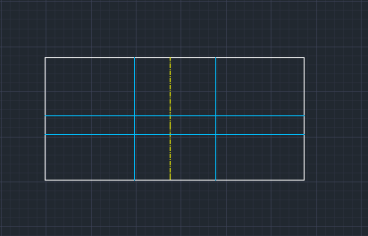

Figure 1:

**Object 2**

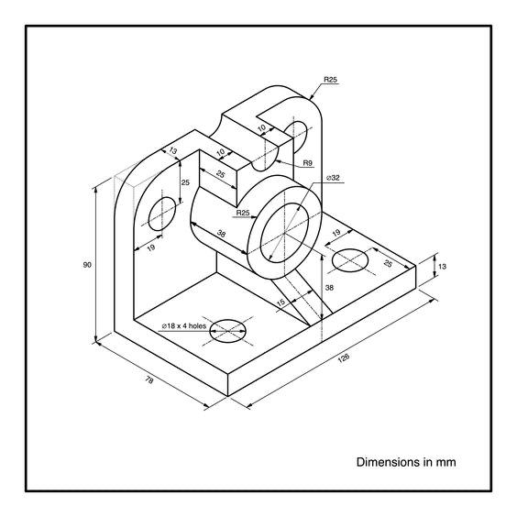

**Drawing:**

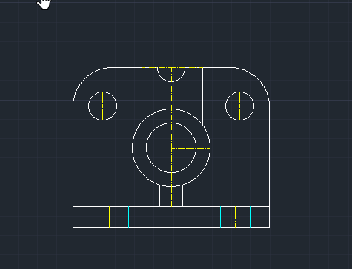

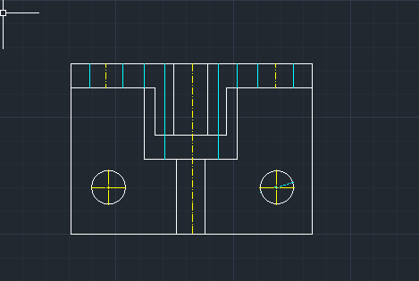

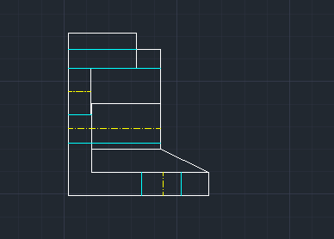

**Question 3**

**Drawing:**

